5 The Wall
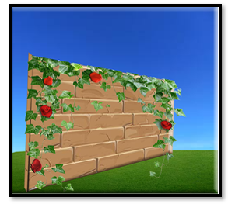

In order to create the wall, we will need a few .png images of the wall. 32px X 32px
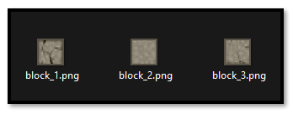
Go into you Game Maker folder for the sprites, and pull out the tile sheet you made for the floor.
C:\Users\Your_User_Name\GameMakerProjects\My First Game\sprites
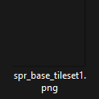
You will want to open your tile sheet in Photoshop

You want to show your grid with 32 x 32 square. Now slide those wall images into the grid spaces beside the wall and save it.
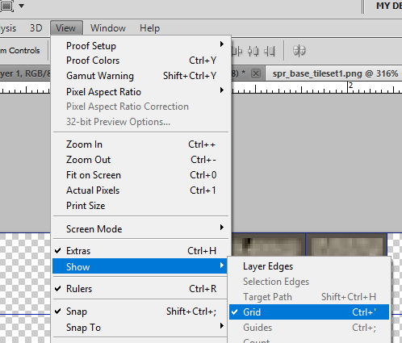
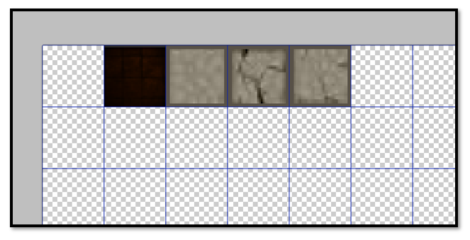
Right click on the sprite_tls_base and select edit. Then you can import your new sprite for this
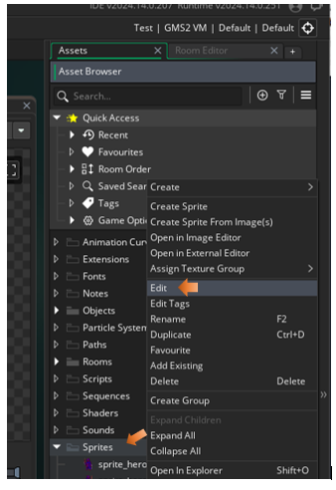
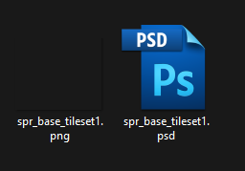
Once you set the new tile set sprite, it will change in the Tile set too. Click on the tileset in the Asset Browser to see it in the Inspector at the left.
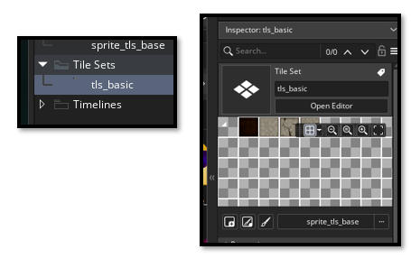

You can add a new layer in the room for the walls, but you do not have to. The wall can go on the same layer as the floor. But since we named our layer for the floor Floor_Tiles, I suppose another layer for wall tiles will make sense. This will be a tile level so select tile for this layer too.
In the Layer panel at the left. Hit the Plus sign and choose Tile
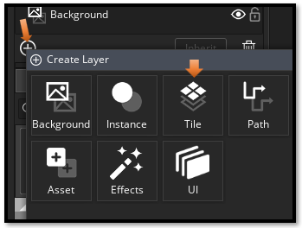
We can name this new layer Wall_Tiles
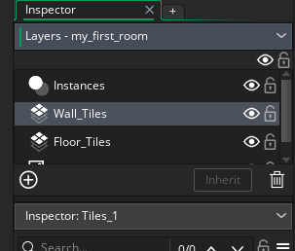
It will want you to select your tile sheet again first.
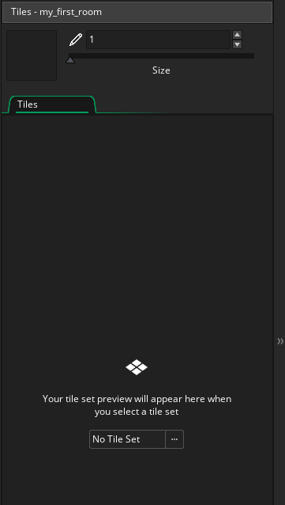
Now with the Wall_Tile layer selected. Click directly on the first wall tile you want to use. For some reason if you do a drag here, it will try to select multiple tiles, and that is not what you want.
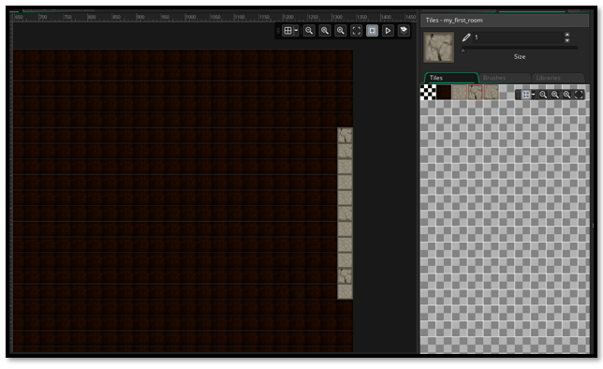
Before we start making the maze we need to create the wall around the room. This wall will prevent the hero from leaving the room. But since we do not have any code for the movement of the hero, or the code to create the collision event that will keep the hero from leaving the room, at this time all you have a wall which is nice to look at.
